Gold Rate Prediction

AIM: Prediction of gold price using timeseries forecasting

DATASET: https://www.kaggle.com/datasets/odins0n/monthly-gold-prices/?select=1990-2021.csv

KEY CONCEPTS:

1. Stationarity
A stationary time series is one whose statistical properties such as mean, variance, autocorrelation, etc. are all constant over time.

2. ADF test (Augmented Dickey Fuller test)
Common statistical test used to test whether a given time series is stationary or not

3. ARIMA (Autoregressive Integrated Moving Average)
A statistical time series model which predicts past values on the basis of future values

- AR (Autoregression): Refers to a model which shows a changing variable that regresses on its own lagged or prior values
- I (Integrated): Difference between static data values and previous values
- MA (Moving Average): Dependency between an observed value and a residual error from a moving average model applied to previous observations

Parameters:
- p: the number of lag observations or autoregressive terms in the model
- d: the number of times the raw observations are differenced; also known as the degree of differencing
- q: the size of the moving average window, also known as the order of the moving average

4. SARIMA (Seasonal Autoregressive Integrated Moving Average)
An extension of ARIMA that explicitly supports univariate time series data with a seasonal component

S (Seasonality): Data variations that occur regularly and predictably throughout a specified period, such as daily, weekly, or annual cycles

Parameters:
- p: trend autoregression order
- d: trend difference order
- q: trend moving average order
- P: seasonal autoregressive order
- D: seasonal difference order
- Q: seasonal moving average order
- m: the number of time steps for a single seasonal period

5. ACF (Autocorrelation Function)
- Graphical representation of the correlation of a time series with itself at different lags
- It can be used to identify the order of an AR model.

6. PACF (Partial Autocorrelation Function)
- Graphical representation of the correlation of a time series with itself at different lags, after removing the effects of the previous lags
- It can be used to identify the order of an MA model.

PROCEDURE:

1. Data Collection and Transformation
- Collecting data from Kaggle
- Transforming the collected monthly data into quaterly data

2. Plotting ACF and PCF graphs
- Plotting ACF and PCF graphs in order to estimate the value of hyperparameters
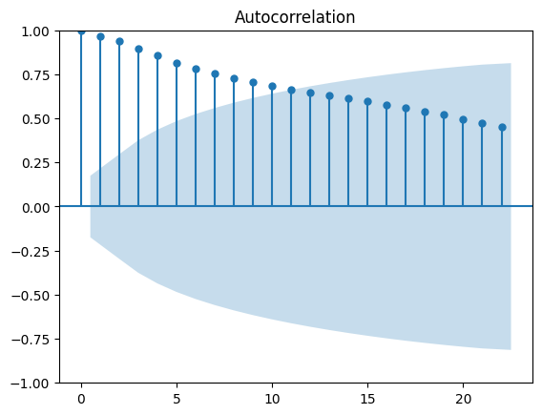
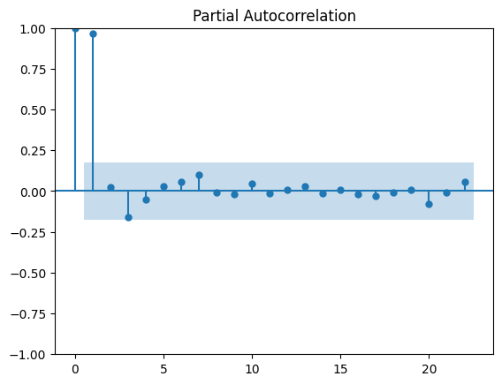
3. Differencing the data
- Differencing the data to make it stationary
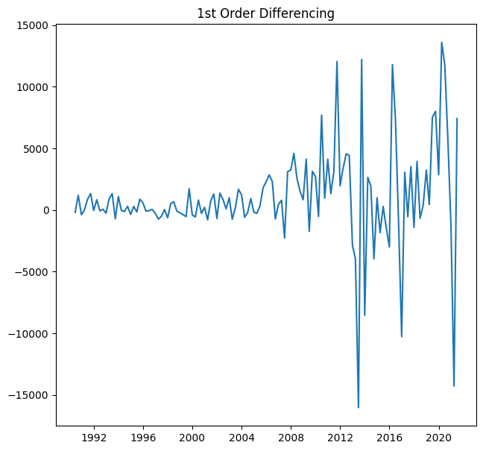

4. Train-Test Split
- Training length: 100 (0-99), 80%
- Testing length: 26 (100-125), 20%

5. Model Training
- Implementing ARIMA and SARIMA models with estimated hyperparameters
- Manually changing the hyperparameters to achieve better accuracy

6. Hyperparameter Tuning
- Giving a range of values to different hyperparameters
- Generating a for loop to get different hyperparameter combinations
- Acquiring the most suitable hyperparameter combination on the basis of pattern captured and least MAPE (mean absolute percentage error)
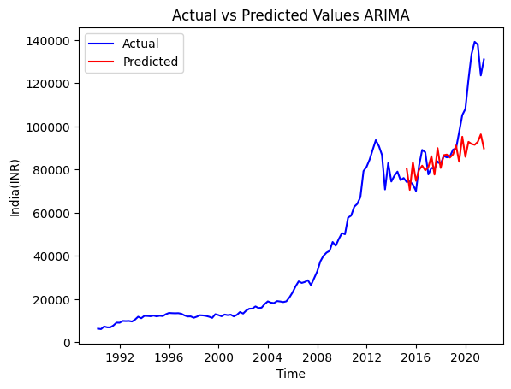
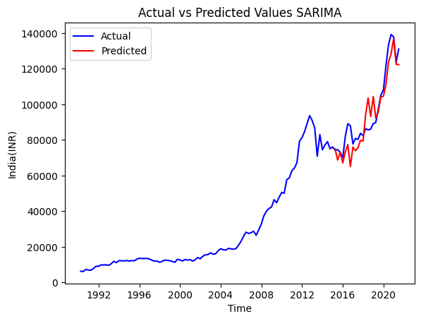
7. Model Testing
- Testing the model on the testing data

8. Taking the differenced predicted values to the original scale
- Using a for loop to remove the differencing from the predicted values

9. Prediction
- Training the model on the entire data using the acquired hyperparameters
- Predicting the next values
- Plotting a graph to show the actual and predicted values
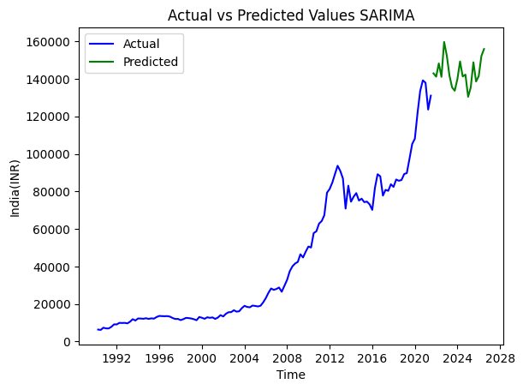
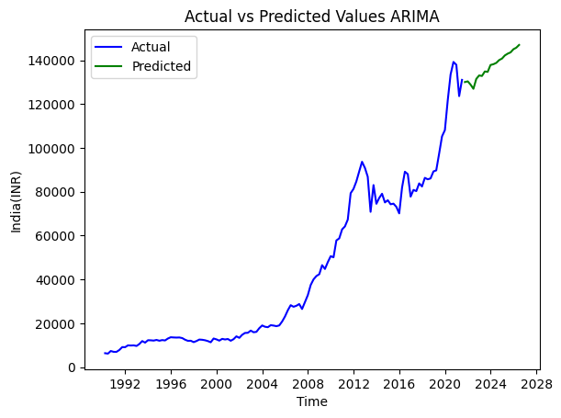

CONCLUSION:

1. ARIMA (7, 0, 1): 0.1168 MAPE
2. SARIMA (7, 0, 1) (8, 1, 8, 4): 0.0706 MAPE

